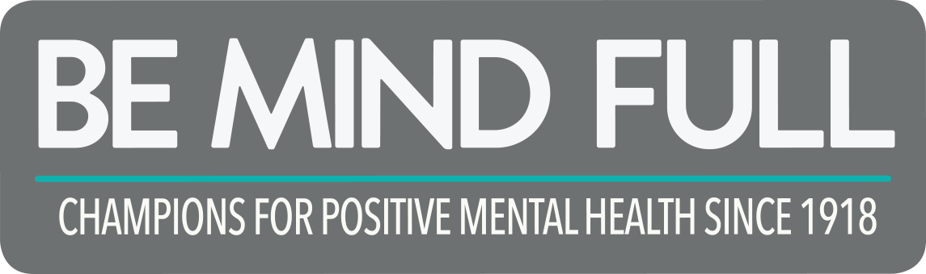



Mentally Healthy People in a Healthy Society
Mission Statement
The Canadian Mental Health Association (CMHA) Prince George Branch exists to promote the mental health of individuals living within the Prince George and surrounding area, and support the resiliency and recovery of people experiencing mental illness.

TABLE OF CONTENTS
Introduction
President’s Report
Executive Director’s Report
Program Manager Report
Manager of Education & Projects

Programs
Bounce Back: Reclaim Your Health
Life Skills Outreach
Forensics Life Skill Program
Peer Support
Connections Clubhouse
Vocational Support Services
Housing Outreach
Moss House
CMHA New Directions Housing
Mental Health and Police Project
Public Education
Heartbeat
Two Rivers Catering
System Navigator
Regional Gatekeeper
Second Chance Thrift Store

Events
Gift of Hope
Mental Health Week
Depression Screening/ Beyond the Blues
Ride don’t Hide

People of CMHA
Board Members
Staff
Volunteers

PRESIDENT’S REPORT
It's been a great year for the board of CMHA. I've now completed one full year as the board president, and the board is functioning very well. We have successfully recruited several new board members, and have lost our treasurer to a new adventure in Ottawa. Two new board members, Yvonne Jones and Kelly Mould, will be joining me in Richmond at the Board Development Conference on September 24 and 25, and we're really looking forward to bringing what we learn home to Prince George
Maureen and her team deserve big congratulations for a hugely successful Ride Don't Hide this year, which exceeded our expectations in a big way. We are also excited about the new plans for Holidays of Hope. One of my favourite parts of the year was the agency retreat, where we worked on a new strategic plan for the agency going forward. It was really wonderful to have so many board members, managers, and employees around the table, and we did some really great work. The board is very happy with the way the agency is working - there will always be challenges, but we know the team at CMHA is working their hardest to meet them.
All the best for the upcoming year.
Carli Staub
EXECUTIVE DIRECTOR’S REPORT
2015/16 has been a very exciting year with growth in programs and partnerships. Our physical move and our increasing involvement in community committees has greatly increased our visibility in the community and beyond. Taking the leap of making our Public Education program full time is a huge step towards fulfilling our mandate to provide ongoing education, information and stigma- reducing opportunities.

Much of this year has also been focused on completing all materials necessary for accreditation and we have submitted everything required and our accreditation application will be up for review this fall. We certainly hope for a solid 3-year approval.

I want to thank a very dedicated Board of Directors – developing a Strategic Plan and assisting with Accreditation has taken a great deal of time and energy and has certainly also assisted with developing a strong Board team. Please take a look at our 2016-2018 Strategic Plan, which is guided by both National and BC Division Strategic plans.

I also want to thank my very overworked management team – without you we could not continue to move forward. The dedication and passion is exceptional!

And of course I have to mention all the front line staff who continue to weather internal and external change with their ongoing focus on what is best for the client – without you there is no CMHA.

Also it is very important to honor and thank all the volunteers who have put in hundreds of hours. Whether that is supporting peers on the psychiatric ward or putting up posters for Ride Don’t Hide or cooking and serving at Gift of Hope – your involvement is critical and goes so far in helping to show others that the stigma of mental illness is a falsehood.

I want to highlight a very special partnership that has occurred this year and will be on display this December – Holidays of Hope has replaced Gift of Hope. It is now a partnership with BC Schizophrenia Society and will greatly assist both organizations to continue to put on a wonderful Christmas event for clients in need.

Maureen Davis MEd
Executive Director
PROGRAM MANAGER REPORT
As a long term employee with CMHA-PG this year has been very rewarding for myself. As my new role as Program Manager starting in September 2015, I have been given opportunities, challenges and rewards. Being faced with new learning, building credibility, knowing my key responsibility areas, identifying top priorities and really getting to know the job, have been some of the challenges.
My learning since I started has been great starting with HEABC webinars and keeping myself updated with the collective agreement, and my travel to Kingston, ONT for our charting system CRMS database. This year has been a learning in progress and will continue for a while yet. Thanks for everyone’s patience.
Staff this year have been doing a lot of learning as well. We had Joanna Pierce and Glen Schmidt, professors at UNBC, deliver a 5 week course on communication, solution-focused methods, trauma-informed practice, strength-based approaches and team building. We also had 2 NHA employees teach Brief Action planning/Goal setting, and our Regional Coordinator Community Gatekeeper Patricia teach our staff Applied Suicide Intervention Skills training.
We are also welcoming to CMHA this year Jennifer Carter and Nicole Antonenko who both contribute great attributes to our agency. Thanks everyone for your great work and dedication this past year!
Jacquie Sketchley

MANAGER OF EDUCATION & PROJECTS REPORT
Changes and growth continue every year with this position, with the change of role of the program manager, I am able to focus solely on Education and marketing of not only our workshops and training but also of CMHA as an organization.
We have been getting more requests to speak at a variety of agencies and organizations. We were invited back again this year to speak to the Second Year Medical Students at UNBC and we are supporting their proposal to include Mental Health First Aid as part of their curriculum. We attended special events and spoke to staff and students at both DP Todd and Kelly School high schools. We partnered with Kelly Road School and John McInnis to pilot the Youth version of LLTTF. We also supported and spoke at the joint event with SD #57 and Kelty Mental Health. We made our yearly rounds to senior facilities, visited the Firepit, and Maureen and Mary Lu were interviewed on CKPG a few times.
In May we attended the CNRE as part of their health fair section and presented an introduction to the Mental Health Works Program. We were featured in an article that was circulated to all major employers after the event.
We continue to attend many health fairs throughout PG and wish to extend a Thank You to our wonderful board members who attended many of these events.
In March I received training to become a facilitator in both SafeTALK and ASIST and look forward to supporting the Gatekeeper program.
Looking forward, I hope to continue to expand our opportunities to present training throughout Northern BC and continue to raise our profile within PG and the North.
Mary Lu Spagrud, BRS

PROGRAMS
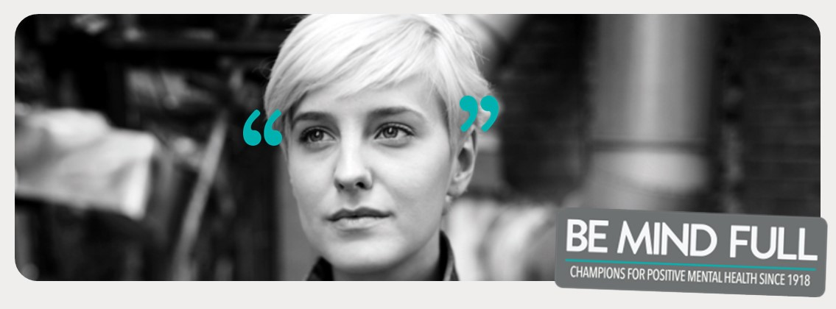

BOUNCE BACK: RECLAIM YOUR HEALTH
Funded by CMHA BC Division
Bounce Back continues to be a very valuable provincial program providing phone coaching services to individuals who are experiencing mild to moderate anxiety and depression. This program is based on Cognitive Behavioral Therapy techniques which is the gold standard for treatment of anxiety and depression.

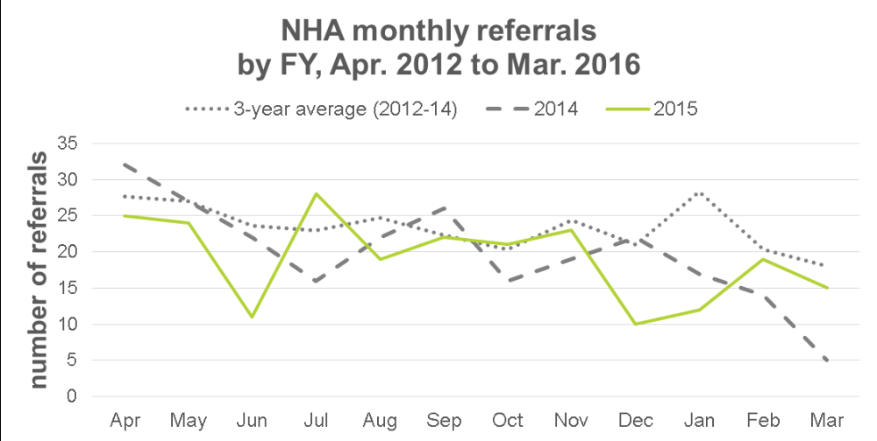
Lory Moroz is our Bounce Back Coach and she was new with us for the 2015/16 fiscal year. She has been working very hard getting all her training on board and going “live”. Bounce Back has embraced the Medeo referral approach and is also now capable of having a video link with clients.

An exciting new endeavor for Bounce Back provincially (although in the 2016/17 fiscal) is the BC Broadcasters award which was won by CMHA BC Division. This has resulted in a 1 million dollar advertising campaign province wide promoting Bounce Back – you will be seeing those ads on TV and Radio.

Lory is also committed to the road trips that are so successful for Bounce Back in the north and involves her driving to the west, the north and the east to ensure that all communities are aware of the Bounce Back program. This is truly an early intervention program that saves lives and dollars.

LIFE SKILLS OUTREACH
Funded by Northern Health
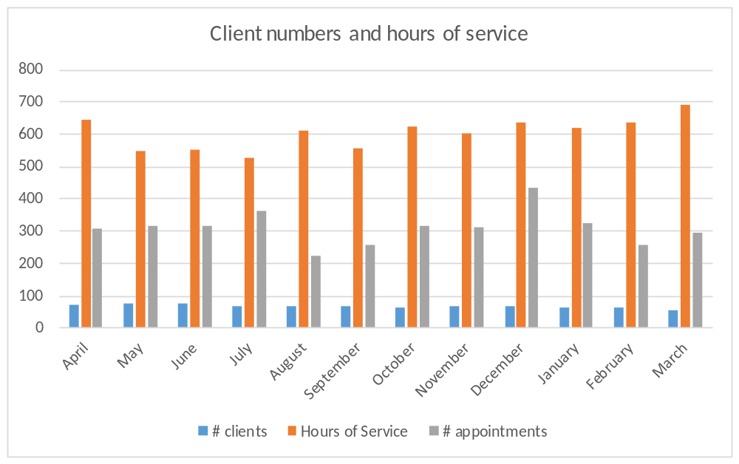
The Life Skills Program continues to be CMHA’S largest community service. Life Skills Outreach provides services to individuals living with mental illness and/or substance abuse issues. The service is designed to promote and assist individuals to gain or regain skills to maintain their independence in the community. Over the past year, our team of 4 full time staff have provided direct service to a total of 68 unique individuals. There were 27 new intakes and 16 discharges this year. Services are provided 7 days a week 365 days of the year. At the end of March this year we had two people referred who were waiting for services. The waitlist for the year has been minimal and the intake delays are most often attributed to the referral needing to be stabilized and/or housed, prior to commencing services. We continue to work with Northern Health to review all clients and their current needs for lifeskills, establishing goals that are SMART (Suitable, Measurable, Attainable, Realistic and Timely) opposed to having long-term support needs that are social supports in nature.
The services provided to our clients are as varied as the individuals themselves: daily life skills such as personal hygiene, laundry, home maintenance, grocery shopping, banking and budgeting; and building personal skills in areas such as accessing the community and learning to manage their anxiety. Staff also provide support with attending appointments, addressing medical needs and adhering to medication needs.
Participation in case conferences with our clients is an important element of the overall case planning that takes place. With many changes in Northern Health’s clinical team, the life skills staff have committed to regular and ongoing engagement with the clinicians to assist in supporting the overall wellbeing of the clients we serve without disruptions.

FORENSICS LIFE SKILL PROGRAM
Funded by Forensics
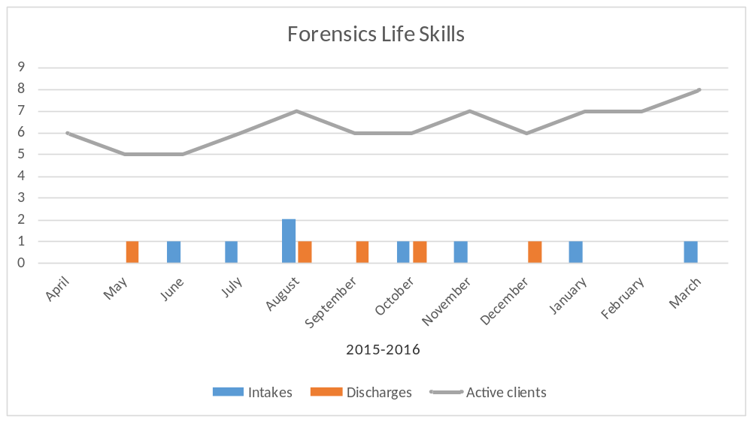
The Forensics Lifeskills Program works with individuals referred by Forensic Psychiatric Services Commission (FPSC). This part-time program provides lifeskills to individuals living with a mental illness and/or addiction, who have been in conflict with the law. Similar to the Lifeskills program funded by Northern Health, the Forensics Lifeskills program provides training to the clients in the areas of budgeting, personal hygiene, grocery shopping, bill payments, medication pickup, medical appointments, banking as well as finding and securing housing. Significantly important to the position is ensuring the staff member is aware of the client’s criminal history, their triggers and signs of concerns that can be identified and reported to the case manager to ensure individual, community and public safety.
“I Martin am new to the Prince George area and have learned a lot of the locations to getting produce and happy to hang with such great company.”
MC receiving Forensic life Skills

PEER SUPPORT
Funded by Northern Health
The part time Peer Support Program (.6FTE) provides a variety of activities to help Mental Health consumers, both in office and outreach in the community. Our employee, Ed Lui, works diligently assisting people with issues involving financial, legal, employment, mental and physical health, accompaniment, access to services, participating in community meetings, finding information and resources and keeping up to date on issues and information affecting the Mental Health Community. The Peer Support Program is a member of the PG Mental Health Consumer Council providing a mentorship role and networking with community partners. This program also coordinates the Positively Peer Program which provides support and information to patients on the psychiatric unit at the hospital. Last year we connected with over 500 individuals receiving services at our hospital. Our Keeping in Touch program is another valuable peer program that provides phone support for those individuals who have left an institutional setting and benefit from a supportive weekly phone call to help them transition. This program serves 8-10 people a week and made 420 calls last year.
Overall the program served 2,591 individuals, either by phone or in person with a wide variety of needs. 143 were males between the ages of 18-29. The bulk of the clientele are between the ages of 30-64 with 936 males and 1033 females. For those 65+ the bulk of the clientele is male at 401 clients compared to 78 females. Ed is a very busy individual who is very focused on developing new services to meet the needs of the people who come to him.
In the past fiscal year Ed and our graduate student Chris Brannigan partnered to provide a group focused on peer mentorship and process. This group was well attended and well received. Both Ed and Chris will be continuing this partnership with a similar group to be offered through the Clubhouse.
This program needs to be full time in order to best meet the growing demands of individuals who seek assistance. We have continued to provide Northern Health with our requests for expansion and continue to seek project funding that could also assist.

CONNECTIONS CLUBHOUSE
Funded by Northern Health, Sales and Fundraising

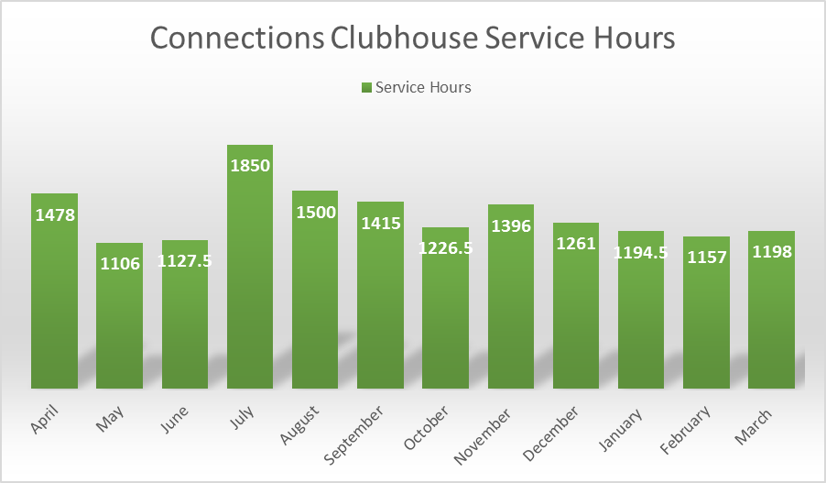

Connections Clubhouse is a social/recreational program of CMHA and membership is open to anyone with mental health/addictions issues and provides a variety of social and recreational activities to its members as well as lunches/brunches served five times per week by Two Rivers Catering. We serve over 300 meals a month and over 4000 in the year.
Over the past year we have provided many activities, some in partnership with the Social committee a joint committee with NHA Recreation dept. and ACE. These events include the Western Carnival, Bocce tournaments, summer “Outdoor Adventure” outings and several dances throughout the year. We had several special in house events this year including our member’s Christmas party and Thanksgiving dinner. Our membership at Connections is at 94 persons and our attendance hours totaled almost 13,000.

“Being with the people here has been a positive impact on dealing with people in a positive way both in the Clubhouse and out in other situations. It has been a great experience for me to be included here.”
MU a member of Connections clubhouse
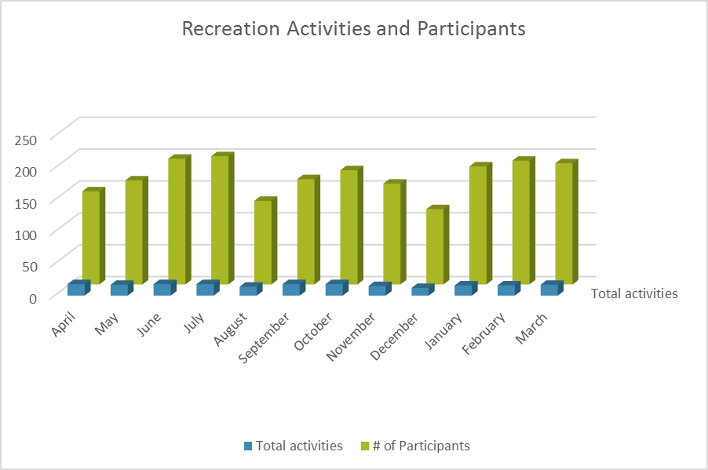

VOCATIONAL SUPPORT SERVICES
Funded by Northern Health

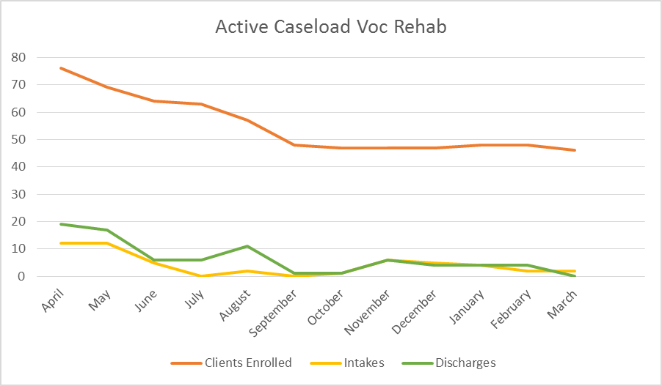

The Vocational Support Program works in conjunction with Rehab Services of the Northern Health Authority. The program goal is to assist individuals with mental illness and/or substance use issues in developing vocational skills which will lead to improvements in job readiness as they work towards paid or volunteer employment or education in their area of interest.

Challenges for the program continue to include needing more community based supported employment/volunteer sites and the time to find and arrange these placements.
We continue to struggle with meeting the 1-1 support needed to assist clients in developing successful placements. We have seen a slight increase in community placements become available this year but are very proud of the successes achieved with an individual graduating the culinary program at CNC as well as 20 placements in paid or volunteer employment.

We were able to provide service to just over 80 clients who nonetheless have benefitted by improving their sense of self-esteem and self-worth as they work towards increased independence while living with a severe and persistent mental illness. Opportunity Fund programming has been very helpful in gaining the supported time needed for employment opportunities and we thank our partnerships with KOPAR, Service Canada and Work BC.

“I was diagnosed with Bi-Polar depression and psychosis two years ago. After 2 stays in the hospital, multiple test and the endless doctors trying to help me and as much as I appreciate their support and care, nothing can compare to the support and care I have received through the Vocational services of CMHA. The vocational services extended many attributes to my wellbeing. Including self-worth, confidence, and strength of the mind, compassion, care and support, not to mention team work, and paying it forward. I would have to say they are heroes.”
RF an individual receiving Vocational Support Services

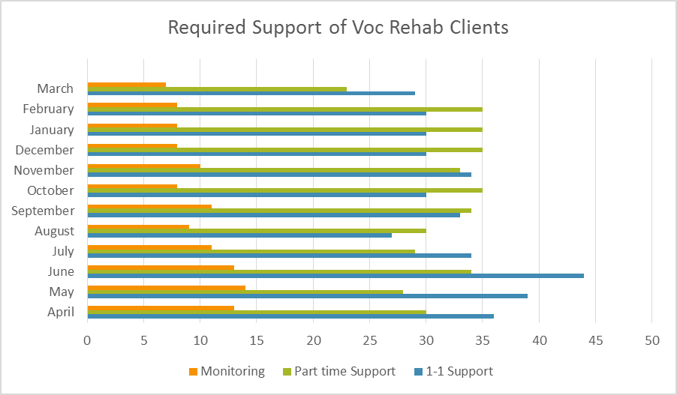

HOUSING OUTREACH
Funded by City of Prince George and United Way
Resource Housing Outreach is a part time position designed to assist people, who are experiencing mental health concerns access affordable and safe housing in the community. Funding for this program is 13 hours per week.
A reduction in 2014 hours also brought fewer numbers of drop-in clients. Not all intakes required housing as some were requesting assistance with applications to BC Housing and SAFER, housing list and apartment manager contact information. Many of the clients were referred to CMHA Resource Housing Outreach by Northern Health, HIP, other agencies, and internally from other CMHA programs.
Rental properties in the bowl area, continue to demonstrate a rapid increase of rental rates and a decline in affordable availability. Continuous relationship building with landlords is an obvious need as competition for rental units increases.
Housing issues faced by persons experiencing mental health concerns who are at risk of homelessness, currently homeless, or in any other way experiencing housing challenges face the same difficulty as any person, however with the added complication of mental health issues and stigma. By making the CMHA’s expertise in Mental Health housing challenges available to agencies, organization, landlords, and individuals, a community of care may be developed to support effective, safe, secure housing in the face of limited availability. This support of existing community services and housing is the direction which the Resource Housing Outreach program is focusing attention and efforts as we enter the new fiscal year.

The housing outreach employee also sits on the Homeless Intervention Project (HIP) which assists people who have been homeless at least a year and have mental health or addiction problems to find proper housing and support services. This committee meets weekly and networks with other community agencies.

In May of 2016, funding was obtained through the IMAGINE: Community Grant. The Association used this funding to train the Outreach worker for Ready to Rent Course, Train the Trainer program. The Outreach worker will be providing the RentSmart course to individuals in the community whom are experiencing difficulties finding and/or maintain housing. The RentSmart Course is a 12-hour course that covers the following:
- Tenant rights and responsibilities
- Landlord responsibilities and expectations
- Living with roommates, housemates and neighbours
- Effective communication skills
- Budgeting and planning for housing affordability and stability
- Maintenance do’s and don’ts
- Crisis management, safety and pests
Upon completion of the RentSmart course, participants earn the RentSmart Certificate of Completion. The certificate can act as a reference and lets landlords know that graduates have learned how to be a good tenant. Please see picture of Jeannine’s graduation as a trainer with Ready to Rent!
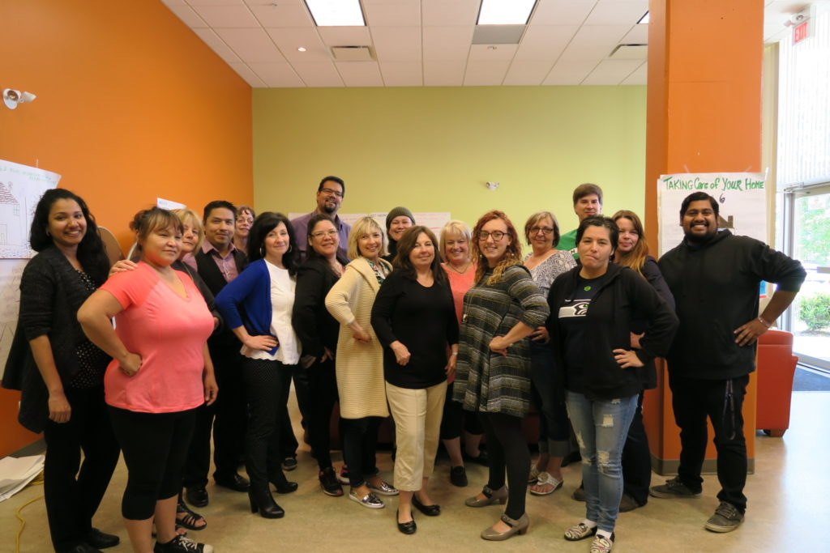

CMHA HOUSING
MOSS HOUSE – Funded by Northern Health and Residents
CMHA Prince George continues to operate a subsidized housing program for individuals with severe and persistent mental illness. Moss House is a 5 bedroom home that is occupied by 5 gentlemen throughout the year. It is a residential setting for those individuals to live in a decent, safe neighborhood and have great interactions with neighbors. Also having a family like environment has provided opportunities for social and group interactions.
The individuals pay a base rental amount and contribute a weekly shared grocery cost that ensures all their food, utilities and housing costs are looked after and any stress is reduced and eliminated so they may focus on their individual wellness. All of the residents are supported twice daily to prompt daily chores, self-care and routine that promotes wellness. The residents are also supported with a one-on-one weekly lifeskills appointment that assists in the development of skills and obtaining the resources and supports that they want and need in their particular living situation. The individuals living at Moss are involved in their community either with work in the private sector or with placements at the Clubhouse.
If and when residents are struggling or doing exceptionally well, they are supported to consider or transition to housing or programming that suit their needs. This year we support one resident to transition to independent living and another resident was supported to attend a short stay at a 24 hour staffed resource and we welcomed a new resident to Moss House. Moss house is home to our residents and continues to be successful.
“I like the environment at Moss House, as well as the program fits my needs. I am also close to work, which is Two Rivers Catering.”
SL resident at Moss House

NEW DIRECTIONS HOUSING
Funded by BC Housing and Residents
NEW DIRECTIONS HOUSING Funded by BC Housing and Residents
CMHA operates subsidized housing units for persons with severe & persistent mental illness. Nineteen units, located throughout Prince George in various apartment buildings, provide individuals with safe, affordable housing with subsidized rents with BC Housing.
Many of our tenants have been in our housing for several years. This year, we had a turnover in three units. Three persons were accepted on the SAFER program, accommodating three new individuals with housing needs. A waiting list exists as the demand for subsidized housing for persons with mental illness far exceeds availability.
This program is supported by a part time position of Housing Administrator whose job it is to maintain close connections with landlords and tenant, identify and ensure correction of deficiencies and act as an intermediary in resolving housing issues such as repair & maintenance concerns, safety concerns, rent increases, financial concerns with housing and so on, without having the clients deal directly with landlords or subsidy providers. This arrangement is meant to assist our tenant by removing housing barriers, leaving them to work on other areas of their goals toward independence and recovery.
The Housing Administrator also sits on the Community Mental Health Housing Committee which meets monthly to determine the best placements for individuals who apply for supported housing. Any openings in our apartments are filled with suitable applicants from the waiting list established within this community committee.

MENTAL HEALTH AND POLICE PROJECT
Participant Time Donation Only
This project is facilitated by Mary Lu and is designed to improve responses by police officers and other first responders to people with mental illness in crisis. Through the involvement of RCMP, people with mental illness, their family members and crisis services such as the BC Ambulance Service and related mental health services including NHA, and community agencies, work is occurring to identify strengths and areas for improvement in our interactions with people experiencing a mental health crisis. This is the ninth year of operation of this committee and of the original nine communities in BC we still continue to be the only one active.
One of the most positive outcomes of this project and training is the stories we hear of police involvement which are primarily positive in nature. We completed 3 one day training opportunities this year and successfully presented one week of CIT training, we partnered with UNBC this year for space. We had a master’s student working with us this year and she completed a report on the overall training we have completed and gave recommendations on next steps and the possible development of a second level or refresher training. There was been renewed interest in the training at a provincial level and we are hopeful this will happen.
PUBLIC EDUCATION
Funded by Sales and Gaming
As stated before we continue to present to a variety of agencies and community partners in terms of specific courses we see steady growth in Mental Health First.
Mental Health First Aid Basic, Mental Health First Aid for Adults who interact with Youth, MHFA teaches participants how to help someone with a mental health problem or experiencing a mental health crisis by identifying danger signs and learning how to take steps to preserve life. It also teaches how to recognize early warning signs of mental illness and how to intervene to support in the recovery of mental health. We presented the basic course eight times this year and the youth course 3 times. Communities included Smithers, Chetwynd, Terrace, Ft St John Mackenzie and Prince George.
Safe and Sound Training, this workshop provides insight into Bill 14’s revisions to the Workers Compensation Act relating to compensation for mental health disorders and how workplace policies can support that act.
Mental Health Works, is the leading go-to program for education, training and consulting needs of employers and employees within Canada and abroad on addressing mental health in the workplace. We presented the introduction module at the Canadian Resources North Expo, as part of their Health Fair Section.
Living Life To the Full is 12 hours that can change your life! This enjoyable, interactive course is taught over 8 weeks and is designed as a group course for anyone aged 19 and over. It introduces the principles of Five Areas of CBT (Cognitive Behaviour Therapy) and will help a person to understand their feelings and what to do about them through worksheets, moderated discussions and booklets for reading and support between sessions. We presented this course once this year but then became a site to pilot the Youth Version. We pr3sented with limited success to two school. The participants gave us wonderfully honest feedback which we are hopeful will be used to improve this presentation.
We are excited to announce the Mary Lu is training to facilitate a resiliency skill training program from the University of Maine call Duct Tape Isn’t Enough. This workshop teaches participants to manage adversity and bounce back quicker. Benefits include improved morale, decreased medical and mental health problems, increased team spirit and cooperation, and better relationships among co-workers and community members. We are planning to be able to start providing this education opportunity this spring.

HEARTBEAT
Volunteer Based Supports
Heartbeat continues to provide valuable peer based support to individuals and families who have lost a loved one to suicide. They meet on the third Monday of each month at 6:30pm at CMHA office and provide support one on one as required. Sandi Galletti continues to be a foundation of this important support service. This program is affiliated with the American Association of Suicidology. As they note – death by suicide is a unique grieving process as “the survivor must grieve not only the loss, but also the choice that caused the loss.” Attached to this process is also the internal and external stigmas that can invite others to seek someone or something to blame for that individual’s choice. This group ensures that the survivors find a way back to a life that understands the choices made and honors the life lived and the lives that continue to be lived.

TWO RIVERS CATERING
Funded by Sales from Catering and the Daily Lunch Program with Gaming support for skills development

Although Two Rivers Catering finished with a financial deficit this year, it was an exceptional year for building the business and for the successes within the vocational clients placed within the program. We have very specific plans for reaching a break even in the 2016/17 fiscal year and currently are well on track for that success.
We provided catering services to over 450 events ranging from small workshops/lunches of 10-12 people up to conferences and weddings with over 150 people in attendance. Our core catering comes from Active Support Against Poverty meal program which brought us $49,000; the Cancer Agency which brought in $13,922 and Northland Hyundai who paid us $19,738 for catering services. Northern Health continues to be a core financial user of this program having purchased just over $18,648 in catering services over the year in many events. Two Rivers catered 3 weddings this year and is a popular choice in the small to mid-sized wedding venue. We had our presence at Kidz Art Dayz as well as provided other community based events. In total we had 44 different purchasers of our services with 40 businesses/non-profits utilizing our catering more than once.
Individuals placed in this program learn all skills related to catering from dishwashing, food safe, meal preparation, presentation, serving as well as learning how to work with a mental illness and the skills to manage a mental illness in the work place. This year we celebrate our first employee who has now made a career choice and graduated from culinary school at CNC. We also celebrate the other huge milestones such as an individual being able to complete a full shift – able to show up on time – able to manage the anxiety of a public venue like a wedding etc. This unique and very valuable program provides the supported venue and life skills to build for success at the individual’s pace but with enough pressure and encouragement to continue to move forward with mental wellness.
As well as the catering services, this program also provides lunches at Connections Clubhouse and serves 15-30 people each day which averages out to over 5,000 meals a year at a minimal cost to the consumer. The left over program and frozen meals is also growing in popularity.
We are right on target with the Business Plan set out in 2013 which highlights that our support of vocational support trainees means that our costs will always be higher than our income and hence the need to have ongoing funds that help offset that cost – gaming provides this essential source of funds and is used to cover the staffing to provide the basic life/work support required in this program and delivered by our Red Seal Chef, Allen Zgaga.

SYSTEM NAVIGATOR
Funded by Community Action Initiatives

On October 6, I was hired at CMHA as the Systems Navigator. As Systems Navigator, I sought out and engaged Support Recovery Homes (SRH’s), learning about their training needs and assisting them in their application to the Community Action Initiative (CAI) training bursary fund of a max of $2500.00. While initially I began with SRH’s in the Bulkley-Nechako and Fraser-Fort George regional districts, my search for SRH’s was expanded to the entire province north of Quesnel. In addition to this, I’ve assisted in other CMHA duties.
As of March 31st, 2016, the accomplishments of the Systems Navigator position included:
*9 SRH’s receiving $14,750.00 worth of various mental health and addictions training
*Attending 4 Outreach events (Beyond the Blues; Homeless Action Week; Christmas luncheon; UNBC Wellness Fair)
*11 workshops and training sessions (Trauma Informed Practice; Mental Health Crisis Response; UNBC Town Planning Day: Regeneration Housing homeless count; BC Non-profit Housing Association Conference; Workforce Mental Health Collaborative; Conflict Resolution Webinar; FASD webinar; BC CRN webinar; Critical Skills For Activating Self-Management webinar; Trauma Informed Practice webinar; Young People, Socio-Economic Processes, and Youth Mental Health Promotion webinar)
*Facilitated February winter bike workshop

There is expected to be more SRH’s applying for training funding. Having joined CMHA’s Ride Don’t Hide committee, I anticipate the late spring and early summer to be a busy time.

REGIONAL GATEKEEPER
Funded by Ministry of Health
The Regional Gatekeeper program is a new initiative funded by the Ministry of Health providing ASIST and SafeTALK training throughout the Northern Health Region. This is a 3 year contract designed to ensure that 2,000 individuals in our region are trained to be gatekeepers in their community to recognize and intervene with individuals who are entering a suicidal state. Patricia Howard was hired for this program and was instrumental at getting the program off to a phenomenal start with trainings in Burns Lake, Kwadacha and at least 8 other communities. Unfortunately we lost her to a full time permanent position at First Nations Health Authority where we wish her well.

We are moving forward with a slightly different variation of service delivery utilizing the community partnerships we already have with the Crisis Line and the Native Friendship Centre. We will be utilizing those individuals who are already ASIST and Safetalk trained (including our staff at CMHA) with providing the actual training and hiring an individual to coordinate and arrange the trainings. This will allow the North to have more funds directed to the high travel costs that are a reality for us.

SECOND CHANCE THRIFT STORE
Funded by Gaming for skills development and Sales
Second Chance, CMHA’s Thrift Store, continues to operate throughout the year, providing low priced used clothing and small household goods to the community. Totally relying on the generosity of donations for our goods, we have been fortunate to have wonderful community support in contributions to keep our racks and shelves well stocked.
We are averaging customers a month and donations have been exceptional this year. The thrift store also assists those individuals setting up a home for the first time with kitchen and household items when available to do so.
Our Second Chance workers do a wonderful job in sorting through donations, doing masses of laundry, ironing, pricing, stocking, cash-handling, learning till and policy procedures, and above all keeping our customers happy.
Financially the store continues to do well with a small profit this year ($298!). As the only sheltered retail spot in Prince George we are vital to the vocational support picture and we are proud to be celebrating our 11th year of operation. We provide Vocational support placement to 10 individuals who all grow in their involvement with the store and CMHA.

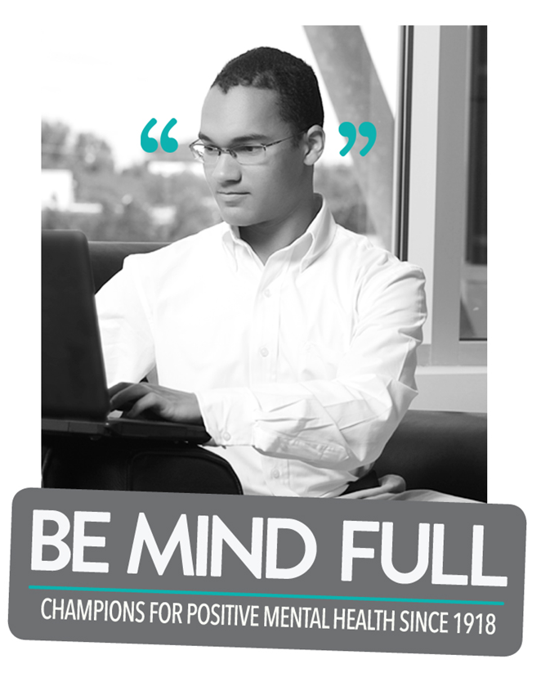
EVENTS

GIFT OF HOPE
Various Donors and Sponsors
For over 20 years, CMHA has provided gifts to individuals living with mental illness and their children. The 2015 Christmas event hosted a Christmas dinner & improv/comedy show with Christmas carol singing which was attended by 200 individuals all due to the generosity of the Prince George community both individuals and businesses. Volunteers contributed hours to sourcing out gifts, putting together the stockings (which had toiletries and winter apparel), and gift delivery as well as countless hours baking and cooking to provide a full course turkey dinner and desserts. A difference in this year’s gift dispersal was an opportunity for each person to choose their gift from tables and tables of new items. The system was well thought out and the attendees enjoyed the process.

Our third year at the South Fort George Family Resource center was again successful.

MENTAL HEALTH WEEK
May 4-10, 2015

Building on last year’s innovative campaign that encouraged people to talk more openly
and honestly about their mental health, CMHA again asked Canadians: “Are you fine or
phine?” But this year, CMHA also asked Canadians to GET LOUD for mental health
because being phine is not fine.
What is “phine”? Too often people claim to be feeling fine when they are not. We are
characterizing this as being “phine”
This year, CMHA is focusing on increasing awareness of men and boys mental health and mental illness by providing information, resources and the practical strategies and advice required to address the mental health and well-being of men and boys.
We provided baskets of resources to traditionally male dominated workplaces throughout Prince George.

DEPRESSION SCREENING/ BEYOND THE BLUES
The 21th annual Depression Anxiety Education and Screening Day in BC took place on during the Mental Health Week in October 2015. We offered screening at UNBC. Our goal was for people to learn the signs of depression, anxiety disorders and risky drinking and help connect to community supports. This event was free, anonymous, and confidential. UNBC was very well attended by students, staff and some high needs concerns were identified. This was an education event and participants did not receive a diagnosis, but learned if they’d benefit from a more complete evaluation. We had over 42 assessments completed and worked with several therapists who volunteered their services for the 4 hours required.
The program included the following:
- A brief depression self-test, anxiety self-test and risky drinking self-test for participants to complete; we asked that everyone complete all three tools.
- A 10-20 minute, one-on-one interview with a clinician to discuss the results of self-tests and next steps. This also included learning about community resources and receiving a follow-up sheet summarizing the results.
- Resource materials on depression, anxiety and related topics.
- A short exit survey for participants to fill out to help us plan and review.
- Activity of making a stress ball
- Refreshments were available

RIDE DON’T HIDE
Sunday June 21, 2015

This year we had 47 riders participate in the Ride with an additional 6 virtual riders raising funds as well. We are pleased to inform you that we made just under $9,500.00 this year.
It was a challenge with the date being the same as Aboriginal day but we appreciate all those who came out and supported us in raising awareness and reducing the stigma of Mental Health.
The riders chose from six-kilometre, 10-kilometer, 20-kilometre and 30-kilometre routes and there were 50 volunteers manning water stations and guiding riders along the routes.
There were about 15 hardcore cyclists who chose to take the 30 km route that included the uphill challenge of university hill.
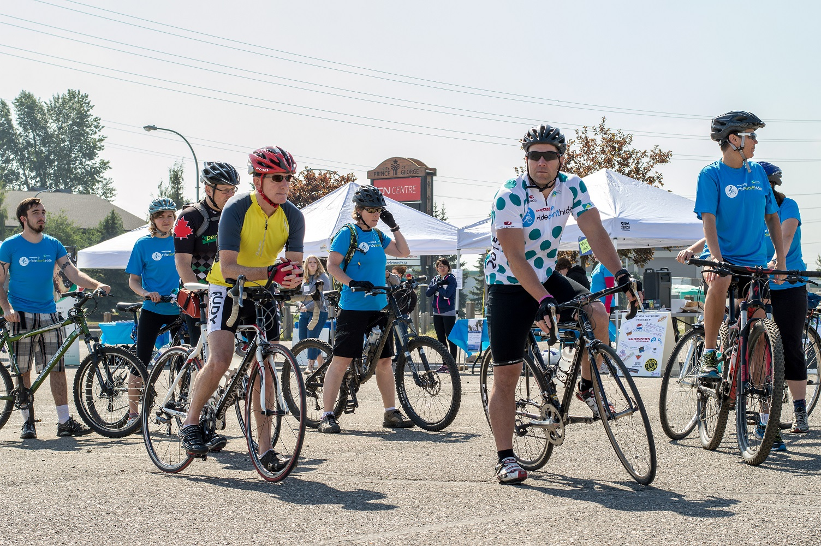

PEOPLE OF CMHA

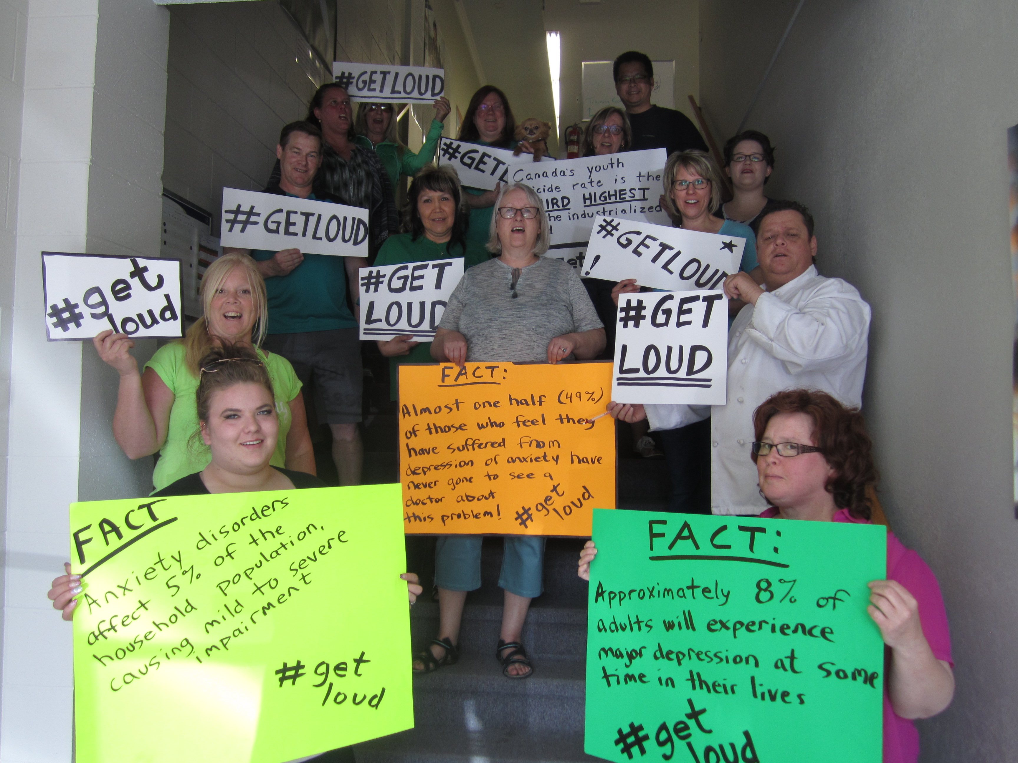

CMHA BOARD OF DIRECTORS
Carli Staub President
Marian Muir Vice-President
Jeffrey Wayow Treasurer
Yvonne Jones Secretary
Alison Barry (moved in September 2016)
Lacy Chabot (left in June 2016)
Kelly Mould
Darlene DeLeon
Ryan James (moved in June 2016)
MariLynn Brooke

STAFF 2015 - 2016

Nicole Antonenko Casual Life Skills
Marie Bradley Vocational Support
Jennifer Carter Casual Life Skills
Jodi Cousins Program Manager
Maureen Davis Executive Director
Lois Doran Life Skills
Rochelle Frigon Administrative Assistant/Volunteer Coordinator
Devon Flynn System Navigator
Jeannine Glowacki Resource Housing
Jeff Hodson Life Skills
Patricia Howard Regional Coordinator Community Gatekeeper
Mary Ellen Johnson Forensic Life Skills
Ed Lui Peer Support
Lory Moroz Bounce Back Coach/Casual Life Skills
Gwen Neufeld Accounting
Clara Orr Life Skills
Jacqueline Sketchley Vocational Support/Program manager
Joy St. Croix Vocational Support
Mary Lu Spagrud Manager of Education & Projects
Heidi Wilson Life Skills
Cheryl Young Vocational Support
Allen Zgaga Chef Two Rivers Catering

VOLUNTEERS
Volunteers are an integral part of the operations of CMHA Prince George. They serve on the Board of Directors and help out with our many events and programs. This work, dedication and sharing of skills that assist us in the successes we celebrate this year. Some choose to provide their services anonymously while others do not mind being acknowledged. In keeping with these differences, we want to acknowledge (without naming) the over 90 people who gave of their time and their hearts to making the world a better place for the people in Prince George who struggle with mental illness and in particular, struggle with the stigma still attached to being mentally ill. The hours of service from volunteers is priceless and in many ways too much to count and will continue to help us work towards our aims of a world where mental illness and mental wellness receive the same level of support, understanding, and care as is typically provided to those struggling to regain physical wellness.

Thank You
We appreciate all you do for and with us!

